
ЧАБАНОВА Жанара Кумыскуловна,
№4 Балжан Бөлтірікова атындағы мектеп-лицейінің ағылшын тілі пәні мұғалімі.
Жамбыл облысы, Қордай ауданы

MY COUNTRY. NATIONAL HEROES.

Learning objectives | 6. 4. 2. 1 understand special information in simple, short texts within a number of general and educational topics without the help of a teacher;  6.5.8.1- spell most high-frequency vocabulary accurately for a limited range of familiar general topics and some curricular topics.
Lesson objectives  (assessment criteria) | Learners will be able to:  - Learn vocabulary for talking about jobs.  - Listen an information about heroes around the world.  - Learn how to describe actions of heroes.  - Respect for real-life heroes and their actions.
Instilling values of the program “Adal azamat” | Honesty and fairness  Unity and solidarity  Diligence and professional competence – respect  Justice and Responsibility  Independence and Patriotism  Perseverance and hard work

Stages/  Time | Teachers actions | Students actions | Assessment | Resources
Beginning  5 min | Greeting. Duty’s report.  Warm up:  Snow ball method. Ask a question in the present simple.  Brainstorming with pictures:  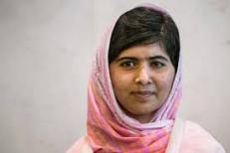  Before we start our lesson, look at the pictures and answer the questions:  -Who are they?  Are they real or fictional?  How do you think about what we will speak today?  Introduce the theme of the lesson:  The topic of our lesson is: Heroes around the world.  Today we are going to talk about heroes around the world  Learn new vocabulary related to heroes  Learn how to describe heroes from different countries  Encourage critical thinking and creativity  Vocabulary Presentation  Introduce vocabulary related to the theme of the lesson. | Duty tells report.  The students ask each other questions in the present tense and answer them in a chain.  Learners look at the pictures and answer to the questions.  Learners try to guess the theme of the lesson.  Learners understand the lesson objectives. | Teacher evaluate pupils with phrases like:  “Good job!  Well done!”  Formative Assessment   | Pictures or flashcards of famous peopleReading text or audio recording  • Worksheet with vocabulary and comprehension questions  PPT
Middle  7 min | Individual work:  Match the words with their definitions.  Students must open the link and complete the activity.  Words: To risk heroism brave kindness to protect to inspire support unity strengths lifesave  Definitions: 1 being strong in body or in mind  2 -to do something that might be dangerous or scary.  3 -to keep someone or something safe from harm  4-being nice and caring to thers  5- not afraid to do hard or scary things  6 -to make someone want to do something good or try hard  7 -to help or take care of  8 -when people work together and help each other  9 -a person who saves someone’s life  10- being very brave and doing something good, even if it’s dangerous | The students open the link and complete the activity | Descriptor:  Students will be able to understand and match key vocabulary words about heroes with their simple English definitions. | Wordwall  https://wordwall.net/resource/100030603
10 min | Pre-listening task:  Before you watch and listen to the information, pay attention to the following questions.  1 What is the name of the heroes?  2 What did she/he do to become a hero?  3Were the heroes real or fictional?  4Do you think these heroes are a real heroes? Why?  5 What qualities helped the heroes succeed?  6 How does these heroes inspire you?  Listening:  Watch the video and pay attention on information, which gives in video.  Post-listening task: Individual work.  Answer the questions related to the video material. | Learners read the questions and understand it.  Learners watch the video and pay attention on information.  Learners answer to the questions individually. | Descriptor:  - answer the questions using critical thinking and your personal opinion. | AI video maker: Pixverse.ai  laptop
10 min | Group work:  Complete a Swot analysis for each.  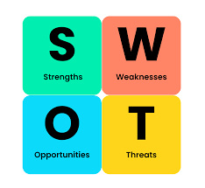  1 group: Malala Yousufzai  2 group: Jose Anders | Learners  In groups make a swot analysis for heroes. | Descriptor:  - are able to clearly identify strengths,weaknesses,opportunities and threats | PPT  Posters  Color pencils
8 min | Conclusion: Free microphone  Make a conclusion and answer to the questions.  1What make a person a true hero?  2Which qualities of a hero would you like to have?  3Why it is important to know about heroes from other countries?  Homework: Find information about other heroes around the world and make a short presentation | Learners answer to the questions and share with their own opinion. | Descriptor:  -answer to the questions clear, give examples and give full answers. | PPT  Microphone
End  5 min | REFLECTION: ‘’2 stars and 1 wish’’ method:  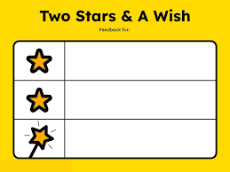  Learners reflect on their learning:  - What has been learned;  - What remained unclear;  - What needs to be worked on.  Saying good-bye | Ss tell about their knowledge according to the lesson |  | PPT

